**FOP LAB TASK 8**

**ABDUL MANAN  
462449**

**SUBMITTED TO SIR AFFAN**

AVERAGE

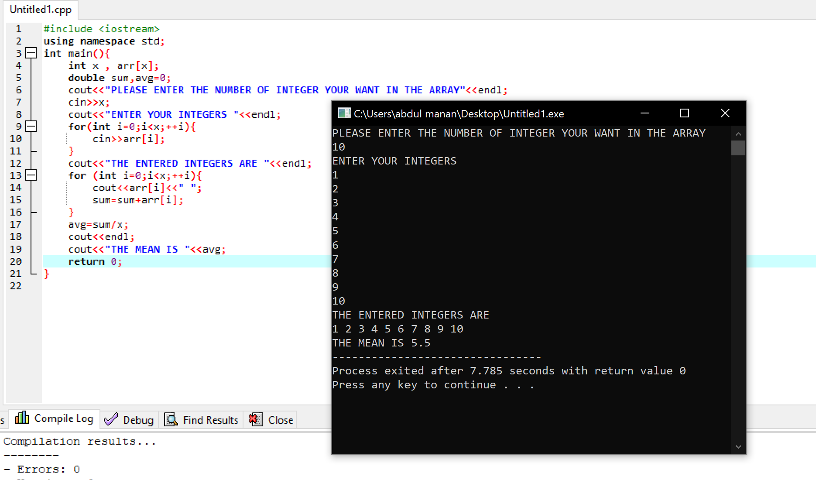

SELECTION SORT

BUBBLE SORT

